LABORATORY OBSERVATION / RECORD

Course: Full Stack Web Development
Course Code: 23CM4121
Experiment No.: 2
Student Name: Kottana Roshini
Roll No.: A24126552263
Date: 06-09-2026

1. TITLE
Design a Styled Webpage Using HTML5 and CSS3

2. AIM
To design and develop a styled webpage using HTML5 for structuring the content and CSS3 for styling it with colours, layout, spacing and hover effects.

3. OBJECTIVE
- To understand the semantic structure of an HTML5 document.
- To link an external CSS3 stylesheet to an HTML page.
- To style page elements using colours, gradients, borders and shadows.
- To arrange content using Flexbox.
- To apply hover effects to interactive elements.
- To verify the rendered output in a web browser.

4. THEORY
HTML5 is the latest version of the HyperText Markup Language and provides semantic elements such as <header>, <nav>, <section> and <footer> that describe the meaning of the content they contain.
CSS3 (Cascading Style Sheets, level 3) is used to control the presentation of HTML elements, including colours, fonts, spacing, layout and animations.
An external stylesheet keeps structure (HTML) and presentation (CSS) separate, which makes the webpage easier to maintain.
Flexbox (display:flex) is a CSS layout model used to arrange the card elements neatly in a row and wrap them responsively on smaller screens.
The basic flow of the application is: HTML structure -> CSS styling -> Browser rendering -> Final styled webpage.

5. ALGORITHM / PROCEDURE
- Create a new project folder for the webpage.
- Create an HTML file (index.html) and define the basic HTML5 structure.
- Add semantic elements: header, nav, section and footer.
- Link an external CSS file (style.css) using the <link> tag.
- Create the CSS file and style the body with a background gradient.
- Style the header, navigation links and their hover states.
- Use Flexbox to arrange the content cards in the container.
- Style each card with borders, border-radius, padding and box-shadow.
- Style the buttons and add a hover effect to change their colour.
- Style the footer and place it at the bottom of the page.
- Open index.html in a web browser to view the rendered page.
- Verify that all styles are applied correctly and the layout is responsive.

6. PROGRAM
index.html
<!DOCTYPE html>
<html lang="en">
<head>
<meta charset="UTF-8">
<meta name="viewport" content="width=device-width, initial-scale=1.0">
<title>My Styled Webpage</title>
<link rel="stylesheet" href="style.css">
</head>
<body>

<!-- Header -->
<header>
<h1>My Styled Webpage</h1>
</header>

<!-- Navigation -->
<nav>
<a href="#">Home</a>
<a href="#">About</a>
<a href="#">Courses</a>
<a href="#">Contact</a>
</nav>

<!-- Content Cards -->
<section class="container">

<div class="card">
<h2>HTML5</h2>
<p>HTML5 provides semantic elements to structure web pages effectively.</p>
<button>Read More</button>
</div>

<div class="card">
<h2>CSS3</h2>
<p>CSS3 is used to style web pages with colors, layouts, animations, and effects.</p>
<button>Read More</button>
</div>

<div class="card">
<h2>JavaScript</h2>
<p>JavaScript makes web pages interactive by adding dynamic functionality.</p>
<button>Read More</button>
</div>

</section>

<!-- Footer -->
<footer>
<p>&copy; 2026 My Styled Webpage. All Rights Reserved.</p>
</footer>

</body>
</html>

style.css
/* Body */
body{
margin:0;
font-family:Arial, sans-serif;
background:linear-gradient(to right,#ffe29f,#ffa99f);
}

/* Header */
header{
background-color:#4a154b;
color:white;
text-align:center;
padding:20px;
text-shadow:2px 2px 5px black;
}

/* Navigation */
nav{
background-color:#6b2d5c;
padding:15px;
text-align:center;
}

nav a{
color:white;
text-decoration:none;
margin:20px;
font-size:18px;
font-weight:bold;
}

nav a:hover{
color:#ffd166;
}

/* Cards Container */
.container{
display:flex;
justify-content:center;
gap:20px;
flex-wrap:wrap;
margin:30px;
}

/* Individual Card */
.card{
width:250px;
background:white;
border:2px solid gray;
border-radius:15px;
padding:20px;
margin:10px;
box-shadow:5px 5px 10px gray;
text-align:center;
}

.card h2{
font-family:Georgia, serif;
font-size:24px;
color:#4a154b;
}

.card p{
font-size:16px;
}

/* Button */
button{
background-color:#e85d04;
color:white;
border:none;
padding:10px 20px;
border-radius:8px;
cursor:pointer;
}

button:hover{
background-color:#9d0208;
}

/* Footer */
footer{
background-color:#4a154b;
color:white;
text-align:center;
padding:15px;
margin-top:30px;
}

7. CODE EXPLANATION
Code | Explanation
<header>, <nav>, <section>, <footer> | Semantic HTML5 tags used to structure the page into meaningful regions.
<link rel="stylesheet" href="style.css"> | Links the external CSS file to the HTML page.
.container { display:flex; } | Uses Flexbox to arrange the card elements in a row and wrap them on smaller screens.
.card | Defines the appearance of each content card: size, border, radius, shadow and spacing.
button:hover | Changes the button's background colour when the mouse hovers over it.
linear-gradient(...) | Creates a smooth colour transition used as the page background.
HTML5 Components Used
- <header> -> Defines the header section of the webpage
- <nav> -> Creates the navigation menu
- <a> -> Creates navigation links
- <section> -> Groups the main content
- <div> -> Creates individual content cards
- <h1>, <h2> -> Displays headings
- <p> -> Displays paragraphs
- <button> -> Creates interactive buttons
- <footer> -> Defines the footer section
CSS3 Properties Used
- background (linear-gradient) -> Adds a gradient background to the page
- color -> Sets the text colour of elements
- border-radius -> Rounds the corners of the cards and buttons
- box-shadow -> Adds a shadow effect around the cards
- display: flex -> Arranges the cards in a row using Flexbox
- padding / margin -> Controls spacing inside and between elements
- text-shadow -> Adds a shadow effect to the header heading text
- :hover -> Changes the colour of links and buttons on mouse hover

8. TEST CASES AND EXECUTION DATA
Test Case | Component Tested | Action / Input | Expected Result | Actual Result | Status
TC-01 | Header & Navigation | Open the webpage | Header and navigation links should be displayed correctly | Displayed correctly | Pass
TC-02 | Content Cards | View HTML5, CSS3 and JavaScript cards | All three cards should be displayed with proper styling | Displayed correctly | Pass
TC-03 | Hover Effects | Move pointer over navigation links and buttons | Hover styles should be applied | Hover effects worked correctly | Pass
TC-04 | Responsive Layout | Resize the browser window | Cards should wrap according to available space | Cards wrapped correctly | Pass

9. OUTPUT
After opening index.html in the browser, the styled webpage is rendered as shown below (colour theme: deep plum header/navigation, warm peach-to-coral background gradient, and orange buttons that turn deep red on hover).
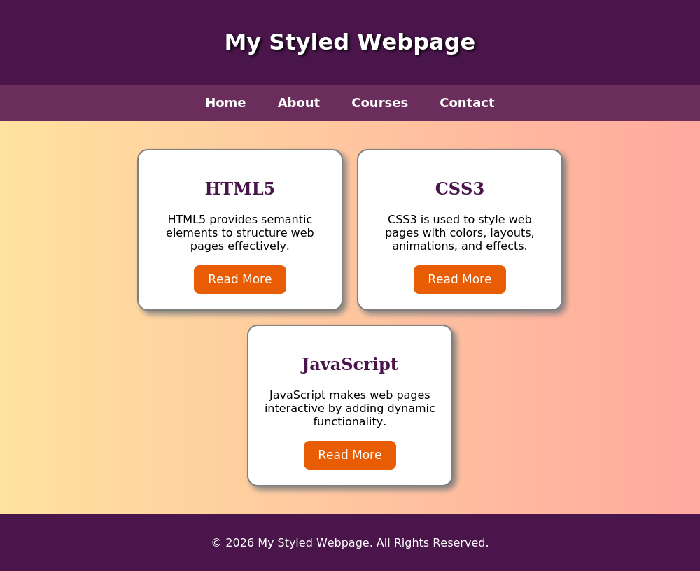

10. RESULT
Thus, a styled webpage was successfully designed and developed using HTML5 and CSS3. Semantic HTML5 elements were used to structure the page, and CSS3 properties such as gradients, Flexbox, borders, shadows and hover effects were applied successfully. The layout was verified to render correctly in the browser.

